Year 7 Science
Introduction to Science
Name: ______________________________ Date: ___________
Class: ____________________

Multiple choice questions
1 | Adam thought that the milk in the fridge had gone ‘off’ because it smelt and tasted a bit different from fresh milk. When he tipped it into a glass it was lumpy.  Which if the following is not an observation of the milk?  A It was lumpy.  B It smelt different.  C It had gone ‘off’.  D It tasted different.  Answer: ___
2 | Which of your senses would be of most use when observing the loudness of thunder?  A Sight  B Hearing  C Touch  D Taste  Answer: ___
3 | Which of your senses would be of most use when observing the length of a leaf?  A Sight  B Hearing  C Touch  D Taste  Answer: ___
4 | Which of your senses would be of most use in observing the amount of sugar in a cup of tea?  A Sight  B Hearing  C Touch  D Taste  Answer: ___
5 | Refer to the drawings of the two animals shown.  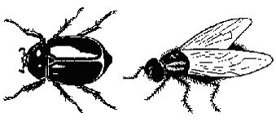  Which of the following statements about the animals above is an inference?  A They both have jointed legs  B One has wings that you can see and the other has not  C They are both insects  D They both have hairs on their legs  Answer: ___
6 | If you put a cool drink with ice into a glass, the outside of the glass feels wet and slippery. If you look carefully you can see tiny drops of liquid which look like water on the outside of that glass.  Which of the following is a reasonable inference (rather than an observation)?  A The glass feels cold  B The glass feels slippery  C The tiny drops of water have come from the air  D Small droplets of water can be seen on the outside of the glass  Answer: ___
7 | Cassie had a small puppy and measured its weight every Saturday morning.  Which of the following is a prediction (rather than an observation or inference) about its weight?  A It weighs 1.2 kg today  B It weighed 1.1 kg last Saturday  C It will weigh about 1.3 kg next Saturday  D Its weight is changing quite rapidly  Answer: ___

8. Give the values shown on the following scales.

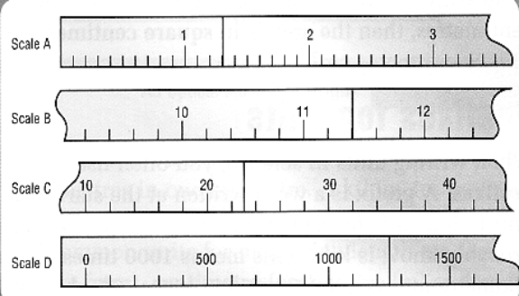
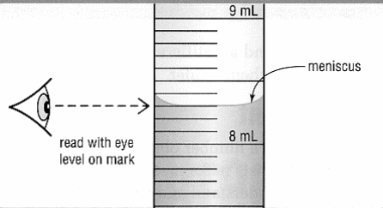
8b__________

8c__________

8d__________

8e__________

8 a_________________

9. Convert the following.

3000 g = kg 4.5 km = m

6.0 min = secs 21.6 cm = mm

497 mm = m 3.5 hr = min

10. Below is a diagram of a garden snail. Assume you have this animal in front of you. Write down six observations you would make of the snail.

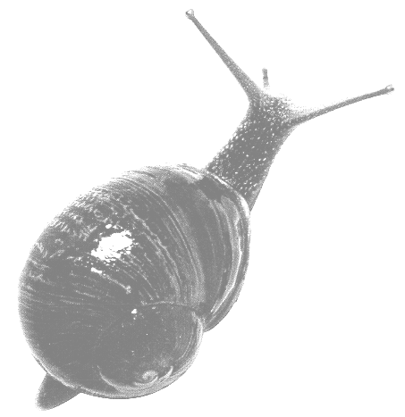
•____________________________________

•____________________________________

•____________________________________

•____________________________________

•____________________________________

11. Complete the following table of observations and inferences.

OBSERVATION | INFERENCE
A lawn mower is heard running out the front of a neighbouring house.
The leaves on a small tree are turning yellow.
A cushion is torn on the lounge and the cat has some fabric on its claws.
The glass of Coke on the table has no bubbles in it.
A test tube goes cold when two chemicals are mixed in it.

12. Make an observation, inference and prediction for each picture

Observation _______________________________________________
_________________________________________________________
Inference _________________________________________________
_________________________________________________________
Prediction ________________________________________________
_________________________________________________________

Observation _______________________________________________
_________________________________________________________
Inference _________________________________________________
_________________________________________________________
Prediction ________________________________________________
_________________________________________________________

